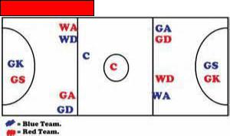[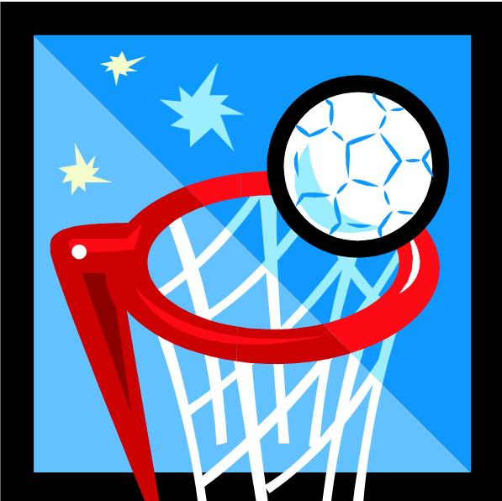](https://www.google.com/url?sa=i&rct=j&q=&esrc=s&source=images&cd=&ved=2ahUKEwianvqe3ordAhUwxYUKHUW6CqsQjRx6BAgBEAU&url=https://bonalyprimaryschool.wordpress.com/school-clubs/netball/&psig=AOvVaw36Ws4ehTGZmlo5LJIzdSls&ust=1535373519323752)

**Playing Area**

**Basic Skills**

Dodging Shooting

Passing Marking

Footwork Blocking

**Positions**

|  |
| --- |
| GS **–** GOAL SHOOTER |
| GA **–** GOAL ATTACK | |
| WA- WING ATTACK | |
| C **–** CENTRE | |
| WD **–** WING DEFENCE | |
| GD **–** GOAL DEFENCE | |
| GK **–** GOAL KEEPER | |

**Governing Body**

The All England Netball [](https://www.google.co.uk/url?sa=i&rct=j&q=&esrc=s&source=images&cd=&cad=rja&uact=8&ved=2ahUKEwiS0crz4p7dAhVjyoUKHTWLBrcQjRx6BAgBEAU&url=https://www.englandnetball.co.uk/big-netball-conversation-back/&psig=AOvVaw1nYjQ-xTgDl5QxgpJQGiuz&ust=1536061969774060)

[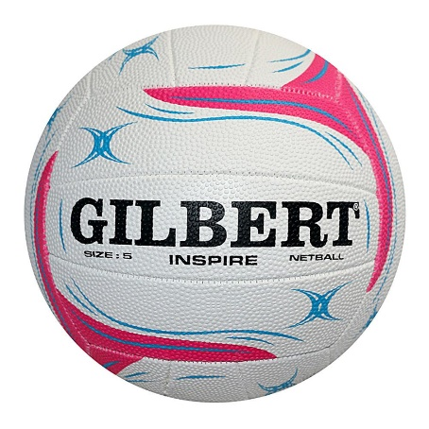](https://www.google.com/url?sa=i&rct=j&q=&esrc=s&source=images&cd=&cad=rja&uact=8&ved=2ahUKEwit9IbP24rdAhXFxoUKHXY5DfkQjRx6BAgBEAU&url=https://sportworx.co.nz/products/gilbert-inspire-training-netball&psig=AOvVaw01ZPMytsT1zzjlBeycYv6q&ust=1535372818996729)

**Relevant Components of Fitness**

**Physical components**

**Endurance –** to be able to perform for the full game at maximum performance levels

**Strength** – to be able to use strength when defending

**Speed** – to be able to get away from your opponent quickly

**Skill components**

**Reaction time** **–** to respond quickly to the movement of a team mate and the whistle

**Agility** **–** to change direction quickly when dodging to get away from an opponent

**Balance** – when passing or shooting the ball

**Equipment / Health & Safety**

**Nails –** must be short

**Jewellery** – No Jewellery worn

**Team bibs** – must be worn to differentiate team and position

**Footwear** – Trainers must be worn

**Tactics & Set plays**

**Centre passes** – Teams create set centre passes so they know who will receive the ball

**Throw in and backlines –** Teams create attacking and defensive set plays so they know who is receiving the ball.

**Rules**

**Footwork** – you cannot move with the ball

**Obstruction** – you need to be 3 feet away from the landing foot

**3 seconds** – you can only hold the ball for a maximum of 3 seconds

**Contact** – you cannot make contact with another player