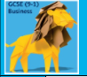
Theme 1 Investigating small business

1.1  Enterprise & entrepreneurship | 1.1.1 The dynamic nature of business | I can explain that businesses operate in a dynamic landscape due to technology, consumer trends and obsolesce.
 | 1.1.2 Risk and reward | I can explain risk and reward for small business owners
 | 1.1.3 The role of business and enterprise | I can explain the difference between goods and services, and how to survive businesses need to provide want consumer want, in terms of adding value.
1.2  Spotting a business opportunity | 1.2.1 Customer needs | I can explain the different needs of customers and explain how these are linked to business success.
 | 1.2.2 Market research | I can explain primary and secondary methods of research with advantages and disadvantages, as well as explain qualitative and quantitative data.
 | 1.2.3 Market segmentation | I can explain why businesses divide the market into customer groups with distinct preferences (segmentation) and how market mapping can be used by businesses
 | 1.2.4 The competitive environment | I can analyse the different offerings of competitors (competitor analysis) in relation to convenience, choice, customer service, price and quality.
1.3  Putting a business idea into practice | 1.3.1 Business aims and objectives | I understand why different businesses will have different aims and objectives, and can differentiate between financial and non-financial aims.
 | 1.3.2 Business revenues, costs & profits | I understand and can calculate: revenue, variable and fixed costs, profits, total costs, interest, break-even and margin of safety
 | 1.3.3 Cash flow | I understand the difference between cash and profit and can calculate cash flow and give solutions to poor cash flow
 | 1.3.4 Sources of business finance | I can describe short term and long term sources of finance, with advantages and disadvantages of each then recommend most appropriate source
1.4  Making the business effective | 1.4.1 Start-up options | I understand the terms limited and unlimited liability, franchisor and franchisee.
 | 1.4.2 Business location | I can explain the factors that will influence location, and also explain how they type of business might be important when considering location.
 | 1.4.3 The marketing mix | I recognise the dynamic nature of the marketing mix (4P’s) and can explain how changes in technology affect the mix.
 | 1.4.4 Business Plans | I know the importance of a business plan, its contents and its role in reducing risk for a small business, and attracting better finance rates.
1.5  Understanding external influences on business | 1.5.1 Business stakeholders | I know how stakeholders can impact business, their different needs and wants and how this can lead to conflict.
 | 1.5.2 Technology and business | I am aware of technological developments that will impact on small businesses in terms of payments systems, and marketing
 | 1.5.3 Legislation and business | I am aware of the purpose of legislation and its potential impact on businesses, both positive and negative.
 | 1.5.4 The economy and business | I understand economic activity (GDP) and its impact on unemployment, inflation and sales.
 | 1.5.5 External influences | I understand how businesses have to respond to external influences – exchange rate (SPICED), legislation and technology.
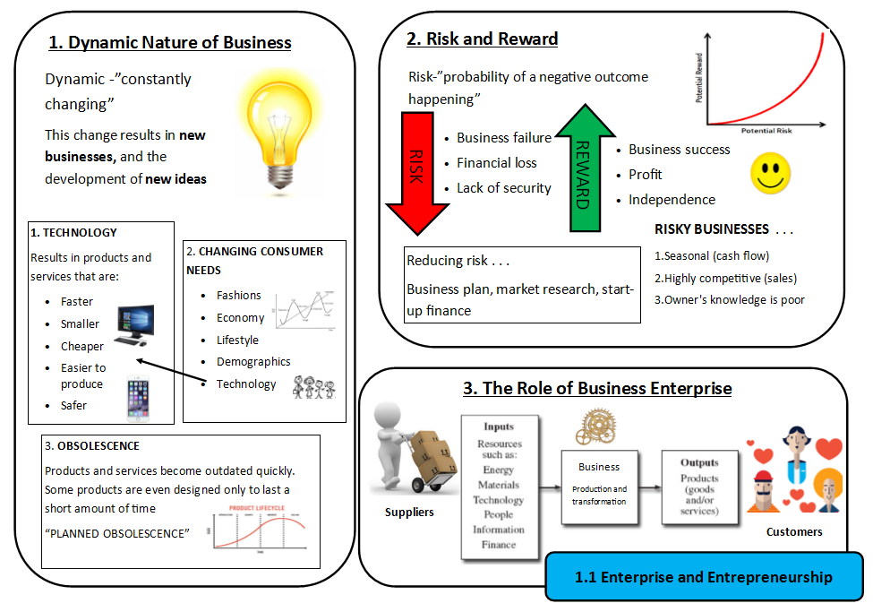
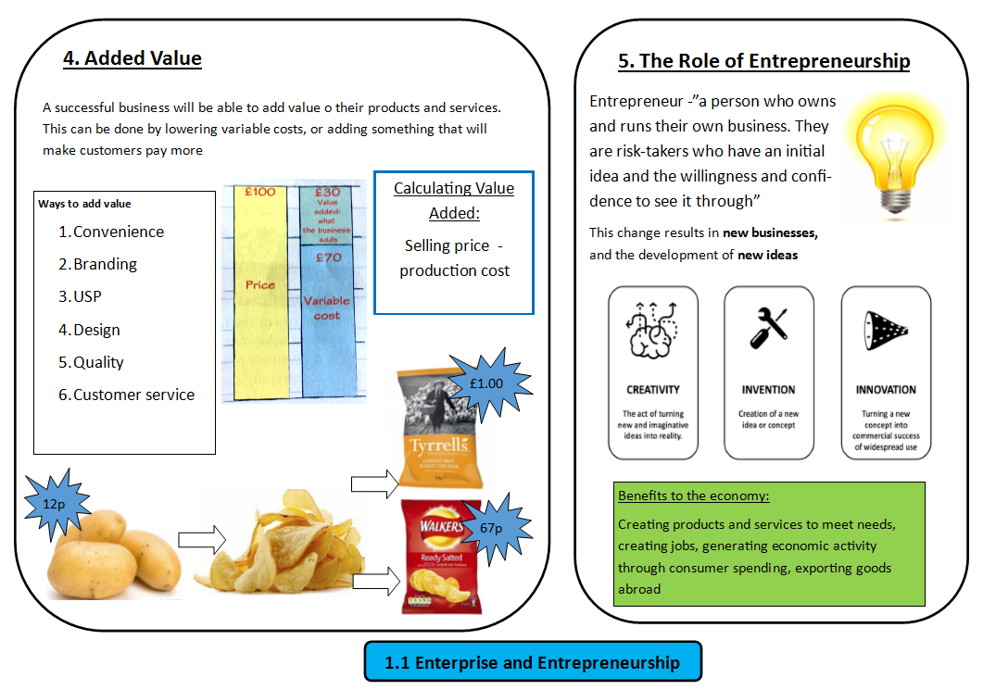
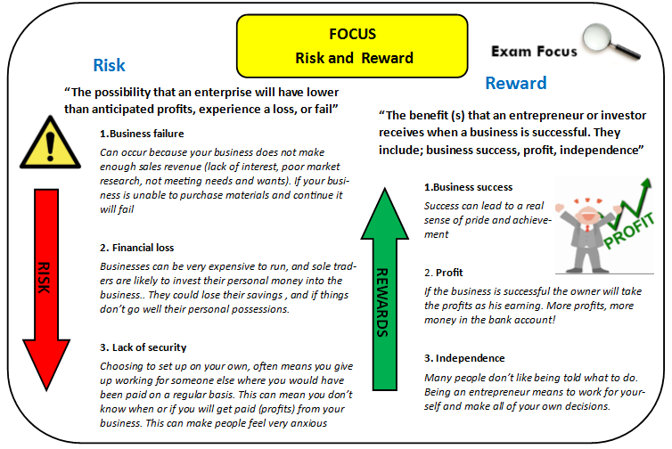
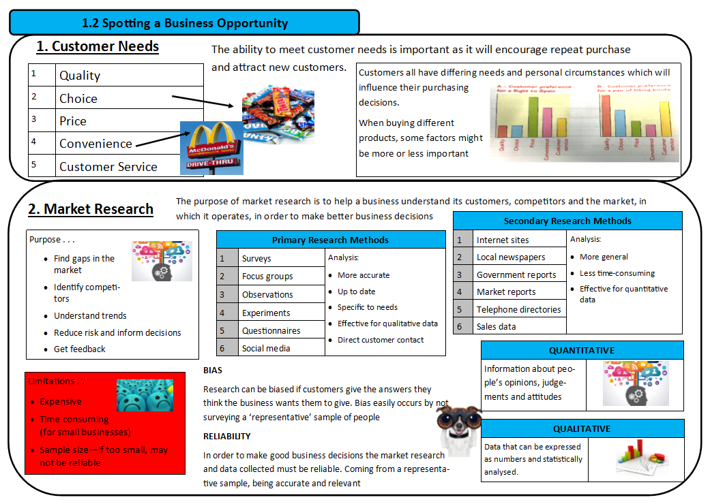
QUALITATIVE
QUANTITATIVE
