KEY

TIMELINE

|  |  |
| --- | --- |
| 1485 | Tudor period begins |
| **1509** | Henry VIII becomes king |
| **1558** | Elizabeth I becomes queen |
| **1588** | Spanish Armada |
| **1603** | Elizabeth I dies and the Tudor period is over. |

WHAT WILL I BE LEARNING ABOUT THIS HALF TERM?

The Tudors

KEY SKILLS

* Bias
* Source analysis
* Chronology
* P.E.E.L
* Comprehension
* Cause and consequence
* Inference

ASSESSMENT

I will undertake a test on the dissolution of the monasteries. I will need to be able to use sources confidently and make inferences. I will use my source analysis skills, especially nature, origin and purpose in order to get a good grade. I will also need to bring in key information from my learning to support my ideas.

BRIEF SUMMARY OF UNIT

I will be studying the Tudor period. I will look at the Reformation and the resulting dissolution of the monasteries. I will also look at Queen Elizabeth I and the Spanish Armada as well as what life was like during this time.

KEY DEFINITIONS

* Primary source –A source made or produced at the time it is discussing/ showing.
* Inference – Reading between the lines
* Monastery – A place where catholic monks live.
* Reformation – Change from the Catholic Church to the Protestant Church in England in 1534

[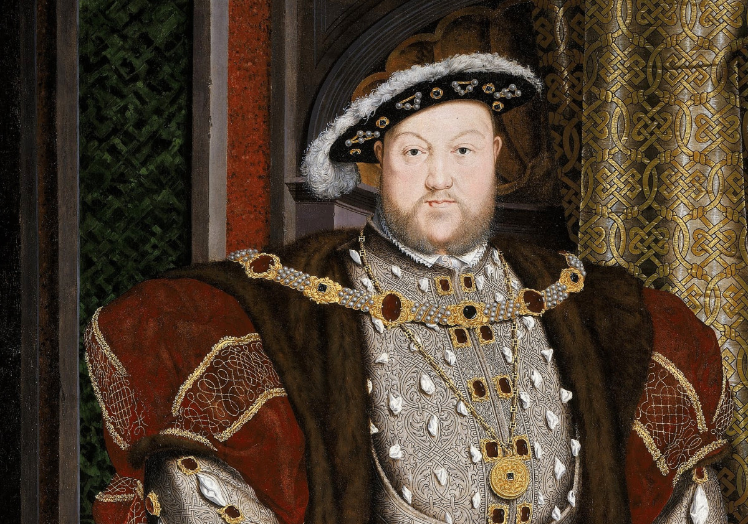](https://www.google.co.uk/url?sa=i&rct=j&q=&esrc=s&source=images&cd=&cad=rja&uact=8&ved=2ahUKEwjGnqDTxcHbAhUF6xQKHXQTBW4QjRx6BAgBEAU&url=https%3A%2F%2Fwww.biography.com%2Fnews%2Fhenry-viii-biography-facts&psig=AOvVaw15kEtO1ld9DVD3G6D2WcnJ&ust=1528460592999770)