**Equipment / Health & Safety**

Never hang or swing on a basketball ring

Wear appropriate footwear

The official size of the basketball used by the NBA is **29.5 inches** in circumference.

**Tactics & Set plays**

In defence a team might use man-to-man marking and defend high up the court in a ‘full court press’ OR defend from the halfway line in a ‘half court press’ OR they might use a ‘zone defence’ and defend areas around their key. In offence a team will use different tactics to move opponents around to create shooting opportunities.

**Relevant Components of Fitness**

**Physical Components**

**Speed** – to be able to drive to the basket to perform a lay-up.

**Aerobic** **Endurance** – to be able to perform for the full game at maximum performance levels.

**Muscular** **Strength** – to be able to protect the ball from defenders.

**Skill Components**

**Agility** – to change direction quickly when dribbling with the ball.

**Balance** – needed when dribbling with the ball and shooting.

**Power** – to jump higher than other players to get the rebound.

**Reaction** **time** – to respond quickly to the movement of a team mate.

**Rules**

|  |  |
| --- | --- |
| Image result for basketball signals 3 seconds | TRAVELLING – a player cannot move with the ball without bouncing it. Also known as ‘WALKING.’ |
| Image result for basketball signals 3 seconds | DOUBLE DRIBBLE – a player cannot dribble using 2 hands simultaneously or after allowing the ball to rest in 1 hand. |
| Image result for basketball signals personal foul | PERSONAL FOUL – when there is illegal personal contact with an opponent e.g. pushing, holding blocking, charging. |
| Image result for basketball signals 3 seconds | 3-SECOND RULE – a player cannot stay in the opponent’s key for more than 3 seconds while their team is in control of the ball. |
| Image result for basketball signals 3 seconds | BACK COURT RULE – once the ball has crossed halfway a player cannot dribble or pass the ball back into the back court. |

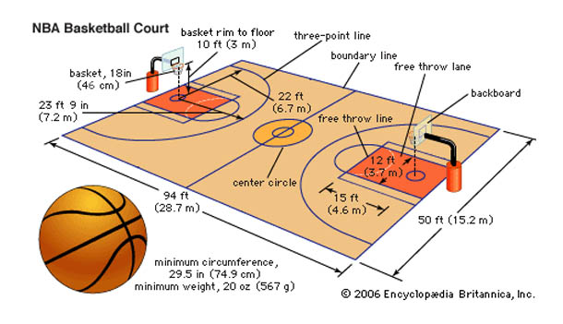

**Playing Area**

**Governing Body**

[](https://www.google.co.uk/url?sa=i&rct=j&q=&esrc=s&source=images&cd=&cad=rja&uact=8&ved=2ahUKEwi71KDh97PdAhVM2qQKHVHRD_AQjRx6BAgBEAU&url=https://twitter.com/bballengland&psig=AOvVaw1xQc8OPkVFd3tSwPaFeylO&ust=1536789119783982)

Basketball England

**Positions**

**point guard - #1 position**

– best dribbler and passer, fast, makes plays for the team.

**shooting guard - #2 position**

– also known as ‘wing’, good at shooting from distance, good dribbler.

**small forward - #3 position**

– good shooter, strong defender, drives at basket and draws fouls, so has to be good from free throw line.

**power forward - #4 position**

– also known as post, plays inside the key, scores close to the basket and mid-range, rebounds, strong defender, blocks shots.

**centre - #5 position**

– tallest player, plays close to the basket, known as ‘low post’, scores close to the basket, rebounds, strong defender, blocks shots.

**Basic Skills**

**DRIBBLING**: bouncing the ball continuously with one hand while moving down the court.

**PASSING**: throwing the ball to a team mate – chest pass, bounce pass, overhead pass, javelin pass.

**SHOOTING**: different methods of scoring in the basket – set shot, jump shot, lay-up, slam dunk.