There are various signals that an umpire uses to show what a batsman or bowler has done.

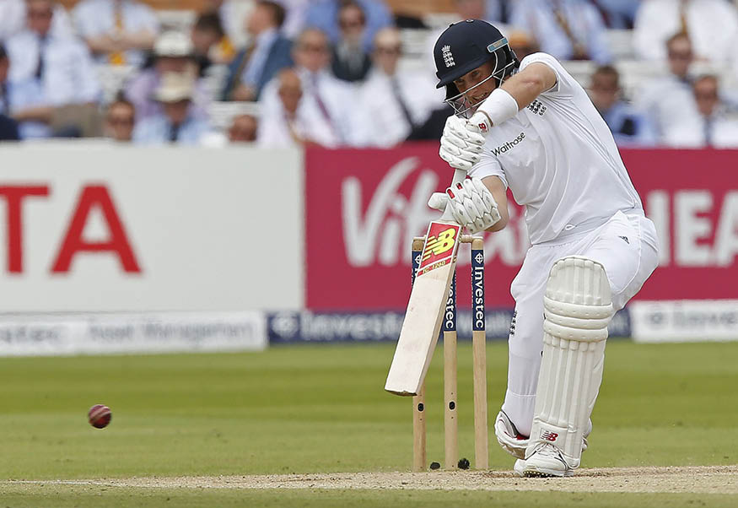

**Relevant Components of Fitness**

**Physical Components**

**Speed** – to be able to chase the ball when fielding, to run quickly between the wickets when batting.

**Aerobic Endurance** – to be able to keep bowling as a fast bowler for a long period of time, to be able to keep running between the wickets if you bat for a long period of time.

**Skill Components**

**Agility** – to change direction quickly when fielding, diving for catches.

**Balance** – needed when bowling and when playing shots as a batsman.

**Power** – to be able bowl fast or throw the ball a long way when fielding, to be able to hit the ball a long way when batting.

**Reaction** **time** – to be able to catch the ball when fielding close, to be able to respond as a batsman to fast bowling.

**Equipment / Health & Safety**

**Pads** – the batsmen and wicketkeeper wear pads to protect their legs when facing the bowler.

**Gloves** – the batsmen wear padded gloves to protect their hands, the wicketkeeper wears larger padded gloves to protect their hands when catching the ball repeatedly.

**Helmet** – the batsmen wear a helmet to protect their heads and faces when facing fast bowlers in particular, one or two fielders might wear a helmet when fielding close to the batsmen

**Box** – the batsmen wear this to protect the groin

**Tactics & Set plays**

Conditions can play a part in tactics. Fast bowlers are used to move the ball away from the batsmen to get them out caught behind the wicket (by wicketkeeper or slips) OR to move the ball in towards the batsman to bowl them out or get them LBW. Slow bowlers are used to fool batsmen by spinning the ball. Batsmen will try to hit the ball into gaps between fielders.

**Rules**

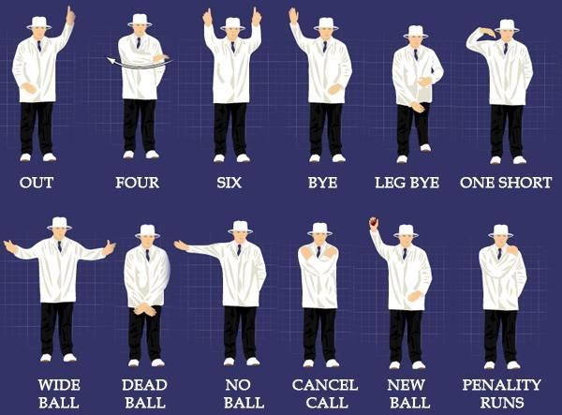

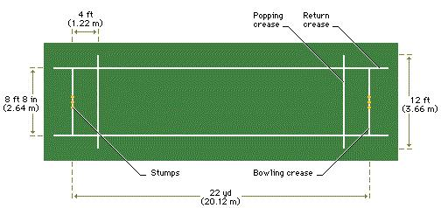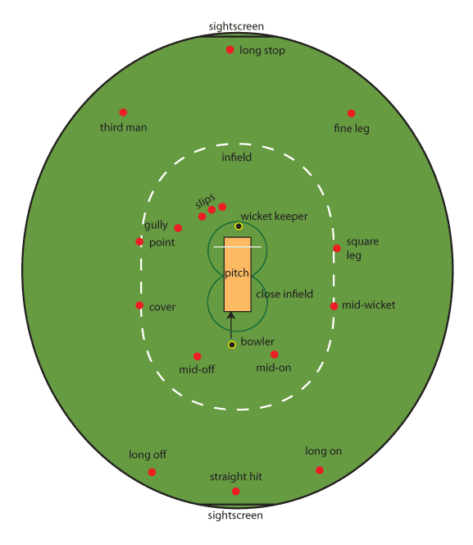

**Positions**

There are numerous examples of fielding positions which can be seen on the large diagram above. There are 11 players in a team and the captain decides where to place his fielders although there is always a bowler and a wicketkeeper.

**Playing Area**

**Basic Skills**

**BOWLING** – A bowler propels the ball towards the wicket defended by a batsman. Some bowlers rely on speed, some bowl slower but spin the ball.

**BATTING** – A batsman defends the wicket by hitting the ball with the bat and tries to score as many runs as possible.

**FIELDING** – when the batsman hits the ball the fielding team collect the ball and try to restrict the number of runs the batsman scores by throwing it back to the wickets where they can run out one of the batsman.

**CATCHING** – if the batsman hits the ball in the air the fielders can try and catch the batsman out.

**Governing Body**



England and Wales Cricket Board