[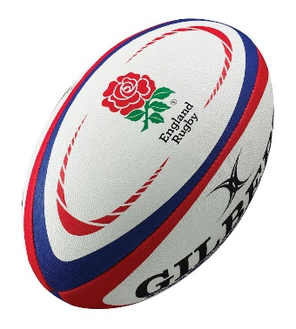](https://www.google.com/url?sa=i&rct=j&q=&esrc=s&source=images&cd=&cad=rja&uact=8&ved=2ahUKEwjRyunDs7PdAhUD1RoKHd0iBCwQjRx6BAgBEAU&url=https://www.simplysports.co.uk/Gilbert-RFU-Replica-Rugby-Ball-p/gilbert-rfu-replica-ball.htm&psig=AOvVaw3HCKWI6NMyNl-EafDg4h5B&ust=1536770803628399)

**Rules**

**Knock on** – If a player drops or fails to catch the ball and it bounces forwards it is deemed as a knock on

**Penalty Kick** – If a foul is committed anywhere on the pitch a penalty is awarded

**Forward Pass** – If a player passes the ball forwards to a teammate a scrum to the opponents will be awarded

**High Tackle** – If a player tackles an opponent above armpit level it will be a high tackle and penalty

**Tactics & Set plays**

**Lineouts** – Short lineout to the front man or a long lineout to the back man. You can also set up a driving maul from the lineout

**Territory** – Playing the game in the opponent’s half by kicking the ball long and making them play from deep

**Drop Goal** – When you are in a position to earn 3 points by drop kicking the ball over the posts

**Getting it Wide** – Using your pacey wingers by getting the ball out to them quickly.

**Equipment / Health & Safety**

**Gum Shields** – must be worn at all times

**Jewellery** – No Jewellery worn

**Team Jerseys** – must be worn to differentiate team and players

**Footwear** – Football boots must be worn

**Headgear/Body Protection** – Can be worn to protect the head and body

**Relevant Components of Fitness**

**Physical Components**

**Aerobic Endurance** – To perform at maximum performance levels and can continue to run and work hard for a full game.

**Power** – To break through tackles or to make effective tackles in defence

**Speed** – To beat opponents to the ball or to go around opponents to score tries.

**Skill Components**

**Agility** – To be able to change direction without losing speed, balance when sidestepping players

**Balance** – Dynamic balance when timing tackles, running with the ball and handing a player off

**Reaction Time** – To respond to the movement of a teammate or an opposition player.

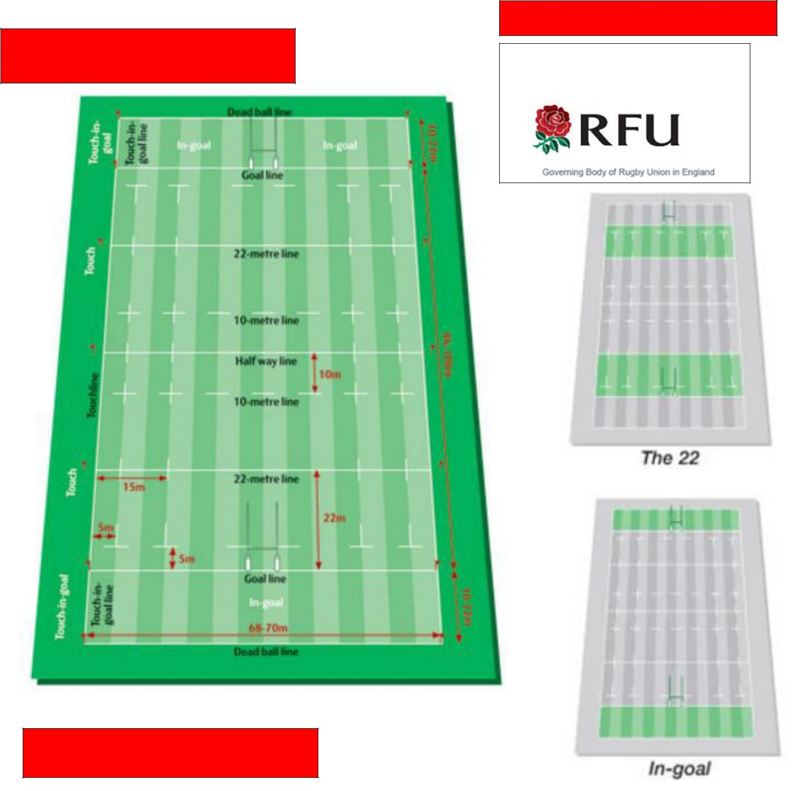

**Playing Area**

[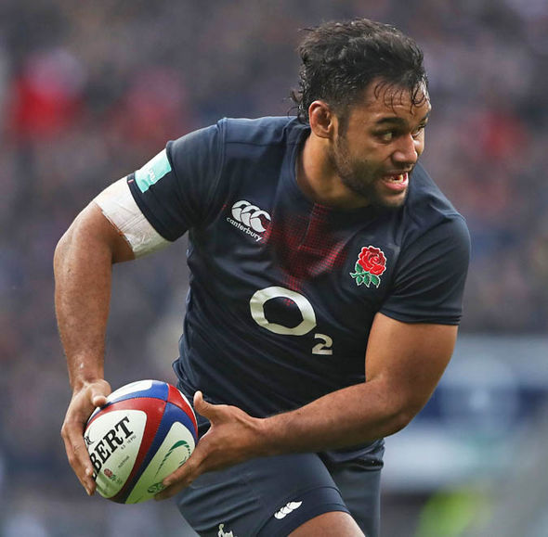](https://www.google.com/url?sa=i&rct=j&q=&esrc=s&source=images&cd=&cad=rja&uact=8&ved=2ahUKEwjxiJnjtLPdAhVHXRoKHVD4DVIQjRx6BAgBEAU&url=https://www.express.co.uk/sport/rugby-union/775331/Billy-Vunipola-Saracens-England-Six-Nations-Scotland-Calcutta-Cup&psig=AOvVaw0zixd6kCZeH0yoaQZ4CFde&ust=1536771132510322)

**Positions**

|  |
| --- |
| Prop  Hooker  Second Row  Flanker  Number 8  Scrum Half  Fly Half  Centre  Winger  Full Back |
|  | |

**Basic Skills**

1. Tackling 2) Rucking 3) Mauling

4) Running with the ball 5) Kicking

6) Handing Off

**Governing Body**

The Rugby Football Union [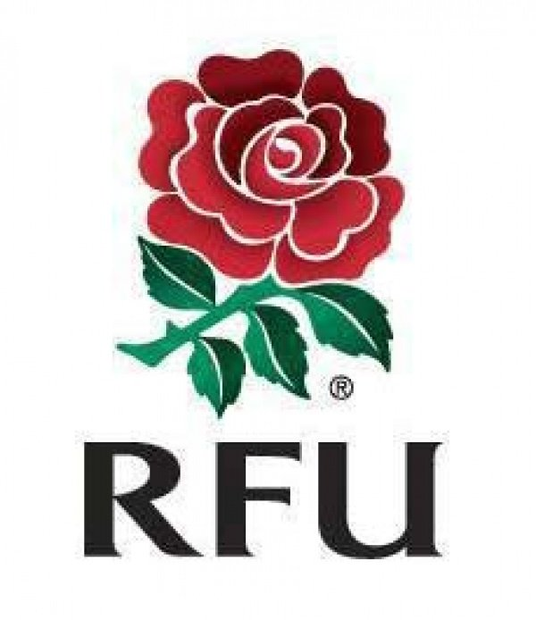](http://www.google.com/url?sa=i&rct=j&q=&esrc=s&source=images&cd=&cad=rja&uact=8&ved=2ahUKEwjnlLuWtLPdAhVBlxoKHRTNAkYQjRx6BAgBEAU&url=http://www.pitchero.com/clubs/cambornerfc/news/rfu-league-restructuring-plans-for-the-201516-seas-1234898.html&psig=AOvVaw1FYQ_L4bFZnEuW6tNdlKyW&ust=1536770981712746)