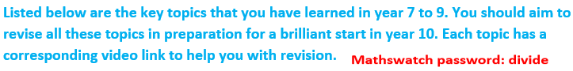
Maths summary for year 9 Standard

NUMBER SKILLS
Topic | Lesson video link
Prime factor tree | https://vle.mathswatch.co.uk/vle/browse/236
LCM and HCF | https://vle.mathswatch.co.uk/vle/browse/238  https://vle.mathswatch.co.uk/vle/browse/237
Reciprocal of a number | https://vle.mathswatch.co.uk/vle/browse/234
Rounding to decimal places | https://vle.mathswatch.co.uk/vle/browse/187
Rounding to significant figures | https://vle.mathswatch.co.uk/vle/browse/248
Estimation | https://vle.mathswatch.co.uk/vle/browse/249
Percentage of a number | https://www.loom.com/share/0aa11c104e444049a7f5c6f97fdc50a9
Fractions: +, -, x, ÷ | https://www.loom.com/share/c00a5fe8951a49ef9fe5a77d8cfebc65
ALGEBRA SKILLS
Expand and simplify algebraic expressions | https://vle.mathswatch.co.uk/vle/browse/295
Factorising simple expressions | https://vle.mathswatch.co.uk/vle/browse/252
Solving equations with letter on one side and both sides | https://www.loom.com/share/87f521db507547e1a62465ca13b5db95
Rearranging equations and formulae | https://vle.mathswatch.co.uk/vle/browse/259
N^{th} term of linear sequence | https://vle.mathswatch.co.uk/vle/browse/261
Substitution | https://vle.mathswatch.co.uk/vle/browse/253
SHAPES AND GEOMETRY
Basic angle facts including special triangles | https://www.loom.com/share/dd344c851c4445f49fe2afc528a3b14b
Angles on parallel lines | https://vle.mathswatch.co.uk/vle/browse/279
Pythagoras’s theorem | https://vle.mathswatch.co.uk/vle/browse/314
Area of rectangle, triangle and parallelogram | https://www.loom.com/share/f7c0467c858f450da97fac3b20e9361c
Area of a trapezium | https://www.loom.com/share/b483cc983efe4cbe9de9877d7bbd8308
Volume of prisms | https://vle.mathswatch.co.uk/vle/browse/278

