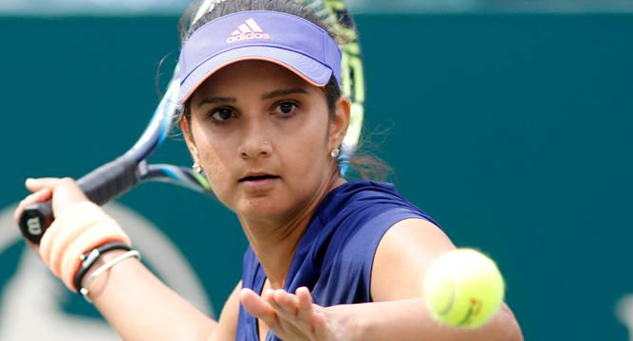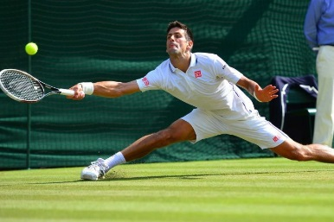

**Relevant Components of Fitness**

**Physical Components**

**Endurance** – Tennis matches can last many hours, so players must have good muscular and cardio-vascular endurance to continue competing for so long.

**Flexibility** – Tennis players must be extremely flexible to be able to play a full range of shots during a match.

**Power -**  Power is very useful in tennis to allow a player to dominate a rally with consistently strong shots.

**Skill Components**

**Coordination** – *Hand-eye co-ordination*is essential for a tennis player to consistently hit the ball cleanly from their racket.

**Agility** – An agile player is more easily able to move around the court quickly, which is vital when playing such a fast game in a small playing area.

**Reaction time** - Tennis players require fast reactionsto be able to effectively return their opponents shots. This is especially important in returning serves.

**Rules**

Tennis matches are played over 3 (Women) or 5 sets (Men).

To win a set, a player must win 6 games and have a 2 game lead. If the scores are 6-6, a tie-break is played. The first to 7 points with a 2-point lead wins the tie-break.

Games are scored in the following increments; 0, 15, 30, 40, GAME.

If scores are 40-40, the game goes to Deuce, and a player must win 2 points in a row to win the game.

**Equipment / Health & Safety**

**Tennis rackets –** Tennis rackets have grippy handles and a large head to the racket, with strings to hit the ball.

**Tennis balls –** Often green so they are easy to see.

**Tennis shoes/trainers** – Correct footwear is important to avoid slipping when moving quickly around the court.

**Tactics & Set plays**

**Serve and Volley** – Some players will choose to rush their opponent by running straight to the net after serving. This may make the opponent panic and allow the server to win the point quickly.

**Baseline players** – An alternative to serve and volley tactics is to stay at the back of the court and try to hit shots into the corners to tire out, or hit a clean winner past the opponent.

**Doubles** – In doubles it is normal for one player to stay forward and the other stay back. When on the attack however, both players may come to the net.

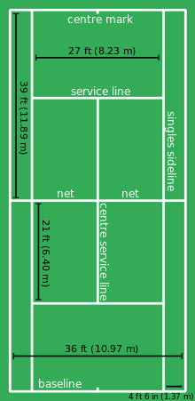

**Basic Skills  
Serve –** The serve is performed by the player tossing the ball above their head and hitting down in an over-arm motion. Serves are hit from behind the baseline and must land in the opposite corner service box.  
**Forehand –** The forehand is a groundstroke, played after the ball has bounced, hit from the player’s **stronger** side.  
**Backhand -** The backhand is a groundstroke, played after the ball has bounced, hit across the body from the player’s **weaker** side  
**Volley –** A volley is a shot played without the ball bouncing.

**Playing Area  
Singles** matches are played up to the **inner tramline.  
Doubles** matches are played across the **whole court,** including tramlines.

**Governing Body**

The **International Tennis Federation** oversees tennis around the world, while the **Lawn Tennis Association** oversees tennis in Britain, including organising major tournaments such as the Wimbledon Championships.