[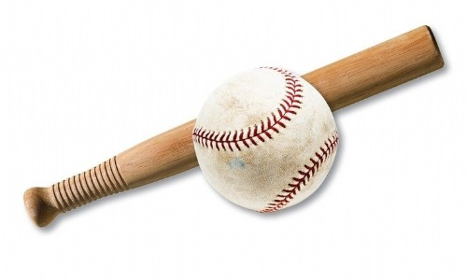](http://www.olcc.lancs.sch.uk/news/?pid=3&nid=2&storyid=1067)

**Relevant Components of Fitness**

**Physical Components**

**Speed** – for getting round all 4 posts at speed to score a rounder

**Strength** – to throw the ball a long distance

**Skill Components**

**Reaction time** – to respond quickly to where the ball has been hit

**Power** – for hitting/throwing the ball a long distance.

**Agility** – To change direction quickly around the posts

**Co-ordination** – to be able to throw and catch the ball.

**Rules**

There are 2 teams – batting and fielding.

**Scoring -** If the batter reaches the 2nd or 3rd post in one hit, the batting team scores ½ Rounder. If the batter reaches 4th post in one hit, the batting team scores a Rounder. The team with the most rounders wins.

**Out when** – Caught, drop the bat, obstruct, step out the front of the batting box

**Bowling** – You must bowl between the batters head and knee and no close or wide to the body.

**Tactics**

**Direction batting** - Batters are encouraged to try and hit the ball in to the spaces.

**Donkey Drop-** This involves the ball being bowled high but by the time the ball gets to the batter it is at the correct height; this means that the batter is more likely to hit it up meaning it is easier to catch.

**Spin Bowling-**By putting spin on the ball it is more likely to go behind, which will mean the batter can only go to first post therefore stopping them from scoring.

**Equipment / Health & Safety**

**PE Kit-** including the correct footwearto reduce chance on injury.

**Post height**- post height must be aminimum of 1m

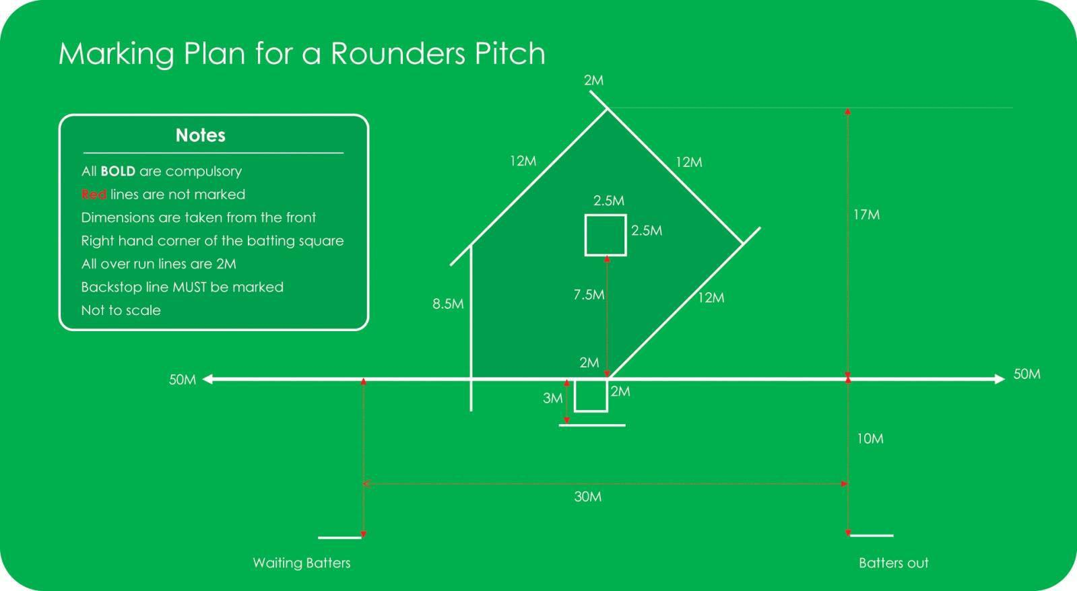

**Positions**

Bowler

Backstop

1st Post

2nd Post

3rd Post

4th Post

1st Deep

2nd Deep

3rd Deep

**Basic Skills**

Throwing Batting

Catching Long Barrier

Bowling

**Governing Body**



**Playing Area**